**Test summary report**

**Content:**

1. **Purpose. 2**
2. **Application overview. 2**
3. **Testing scope. 2**

**3.1. Functional testing. 2**

**3.2. GUI testing. 2**

1. **Test environment and devices. 3**
2. **Metrics. 3**

**5.1. Functional testing. 3**

5.1.1. Xiaomi redmi note 9. **3**

5.1.2. Iphone 7 plus. **4**

**5.2. GUI testing. 7**

5.2.1. Xiaomi redmi note 9. **7**

5.2.2. Iphone 7 plus. **9**

**5.3.**  **Numbers of defects and their severity. 10**

1. **Exit criteria. 11**
2. **Conclusion. 11**

**1. Purpose.**

This document explains the various activities performed as part of the Testing of the "IDS Client" mobile application.

**2. Application overview.**

The IDS Client is an app for managing customers' dancing activities and training from the mobile phone. It applies users to select their training schedules, locations, dance styles, and coaches. Also users can purchase different types of the subscriptions. The app also offers support from the administration of the dance studio.

**3. Testing scope.**

The goal of testing the IDS Client app is to verify the correct operation of all its functional capabilities and the correct display of the graphical interface in different devices using typical user scenarios.

**3.1 Functional testing.**

1. **In scope:**

Functional Testing for the following modules are in Scope of Testing:

* Main processes
* Registration/Authorization
* Main screen
* Buy screen
* Schedules screen
* Dance styles screen
* Trainers screen
* Account screen

1. **Out of scope:**

Security testing, stress testing, and regression testing was not conducted.

**3.2 GUI Testing.**

1. **In scope:**

* Registration form
* Login form
* Password recovery
* Main screen
* Buy screen
* Schedules screen
* Dance styles screen
* Trainers screen
* Account screen

**4. Test environment and devices.**

Mobile application: IDS Client

Version: 1.0

Devices:

1. Xiaomi redmi note 9. OS version: Android 12SP1A.210812.016
2. Iphone 7 plus. OS version: IOS 15.7.2

**5. Metrics.**

**5.1 Functional testing**.

**5.1.1 Xiaomi redmi note 9:**

1. *Numbers of tests planned/executed and passed/failed:*

| Test planned | Tests executed | Tests passed | Tests failed | Tests skipped |
| --- | --- | --- | --- | --- |
| 167 | 164 | 133 | 31 | 3 |

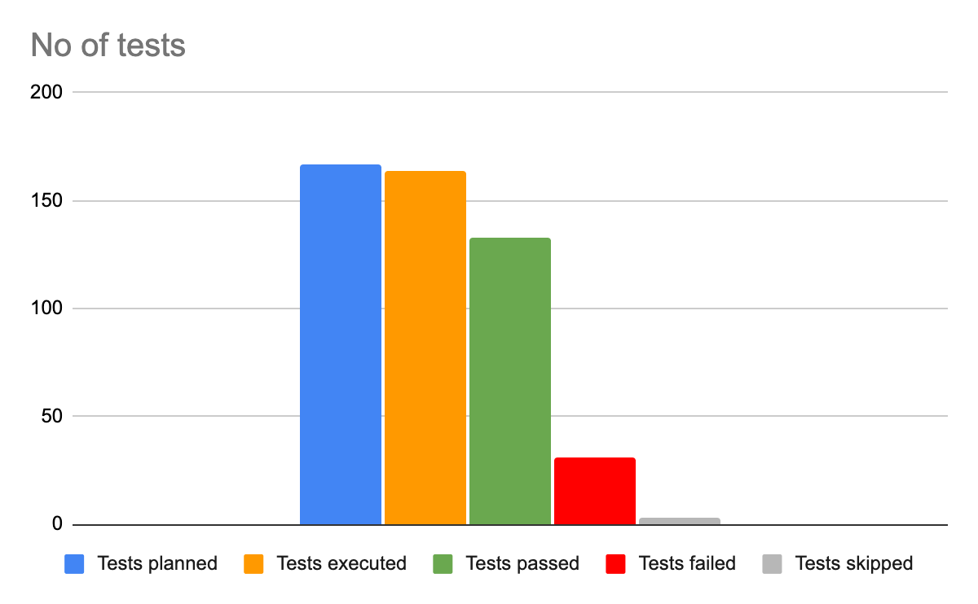

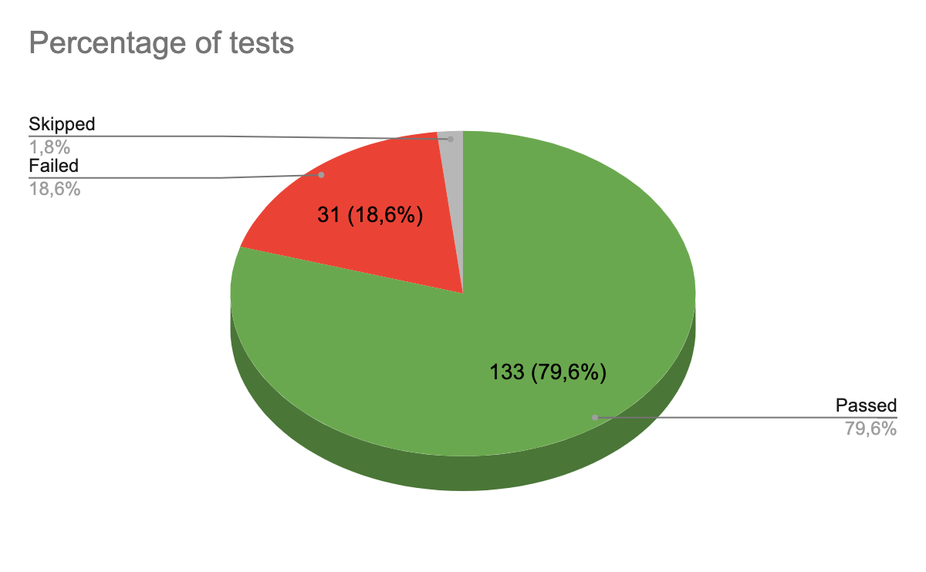

1. *Defects distribution - module wise:*

| Main processes | Registration/ Authorization | Main | Buy | Schedules | Dance styles | Trainers | Account |
| --- | --- | --- | --- | --- | --- | --- | --- |
| 1 | 11 | 3 | 5 | 0 | 1 | 5 | 5 |

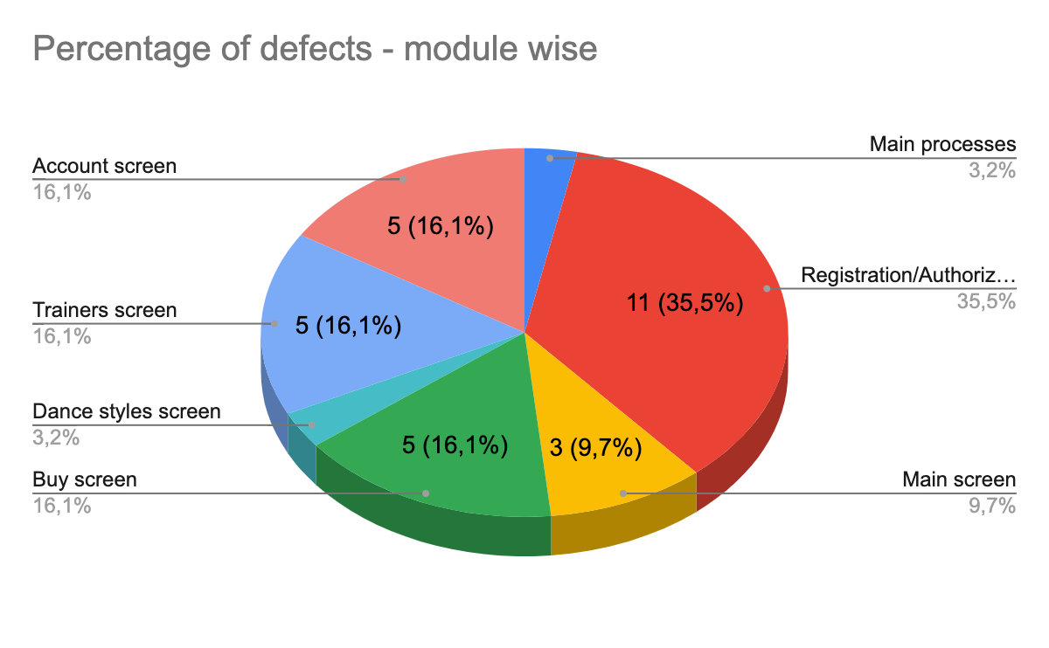

**5.1.2 Iphone 7 plus:**

1. *Numbers of tests planned/executed and passed/failed:*

| Test planned | Tests executed | Tests passed | Tests failed | Tests skipped |
| --- | --- | --- | --- | --- |
| 167 | 164 | 134 | 30 | 3 |

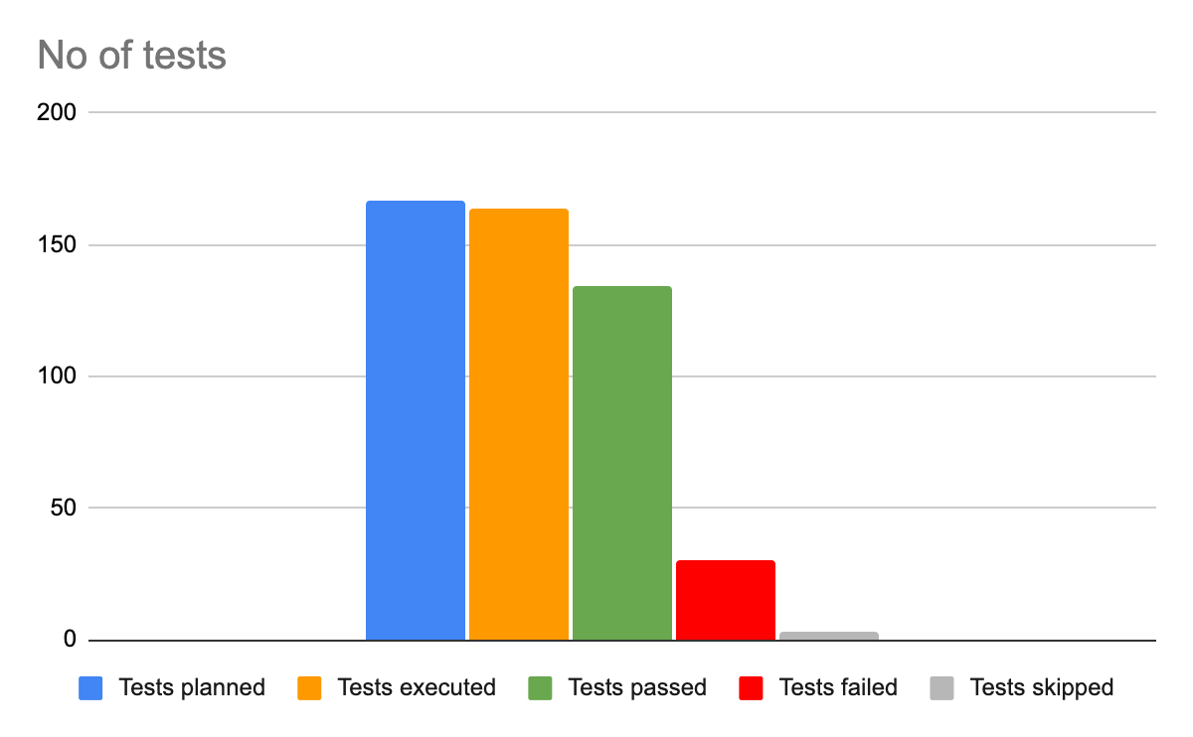

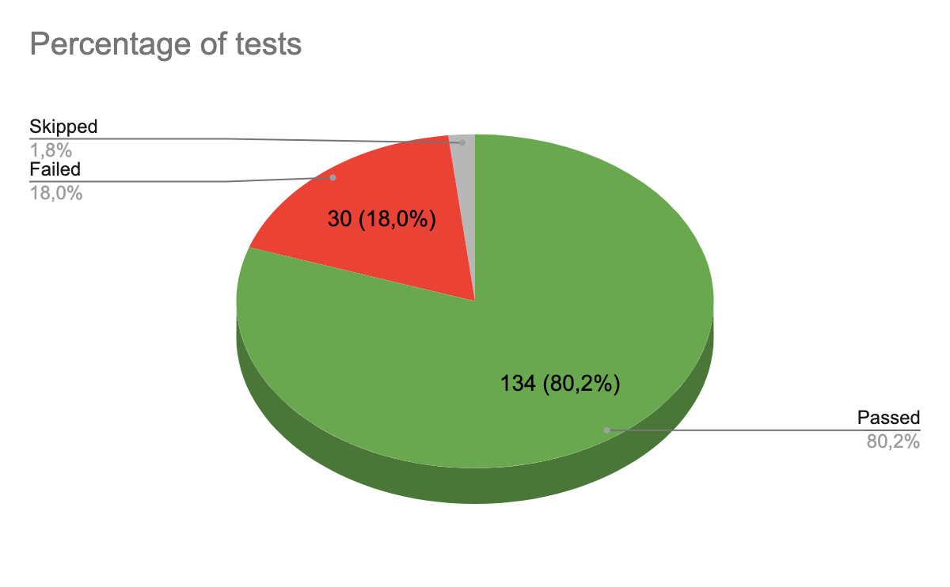

1. *Defects distribution - module wise:*

| Main processes | Registration/ Authorization | Main screen | Buy screen | Schedules screen | Dance styles screen | Trainers screen | Account |
| --- | --- | --- | --- | --- | --- | --- | --- |
| 2 | 11 | 3 | 4 | 0 | 1 | 5 | 4 |

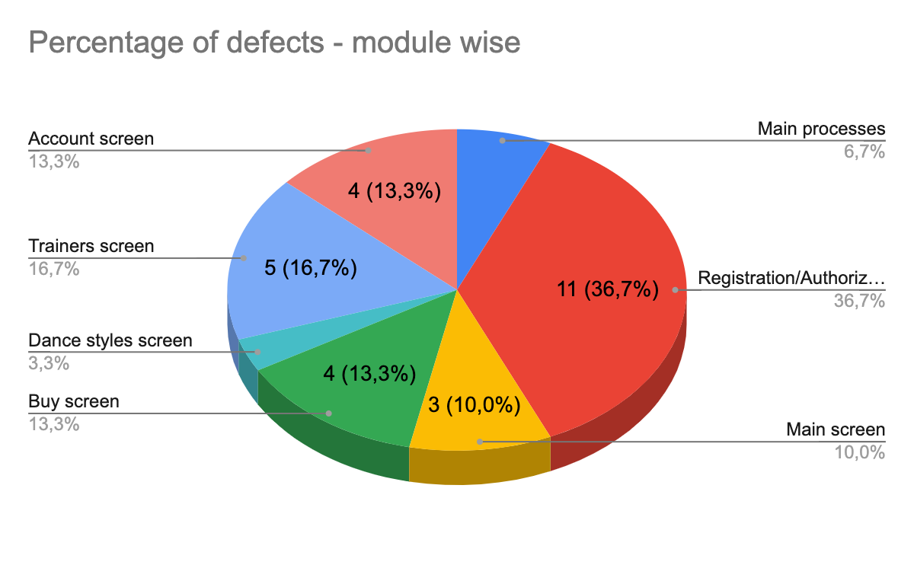

**5.2 GUI testing.**

**5.2.1 Xiaomi redmi note 9:**

1. *Numbers of tests planned/executed and passed/failed:*

| Test planned | Tests executed | Tests passed | Tests failed | Tests skipped |
| --- | --- | --- | --- | --- |
| 170 | 168 | 143 | 25 | 2 |

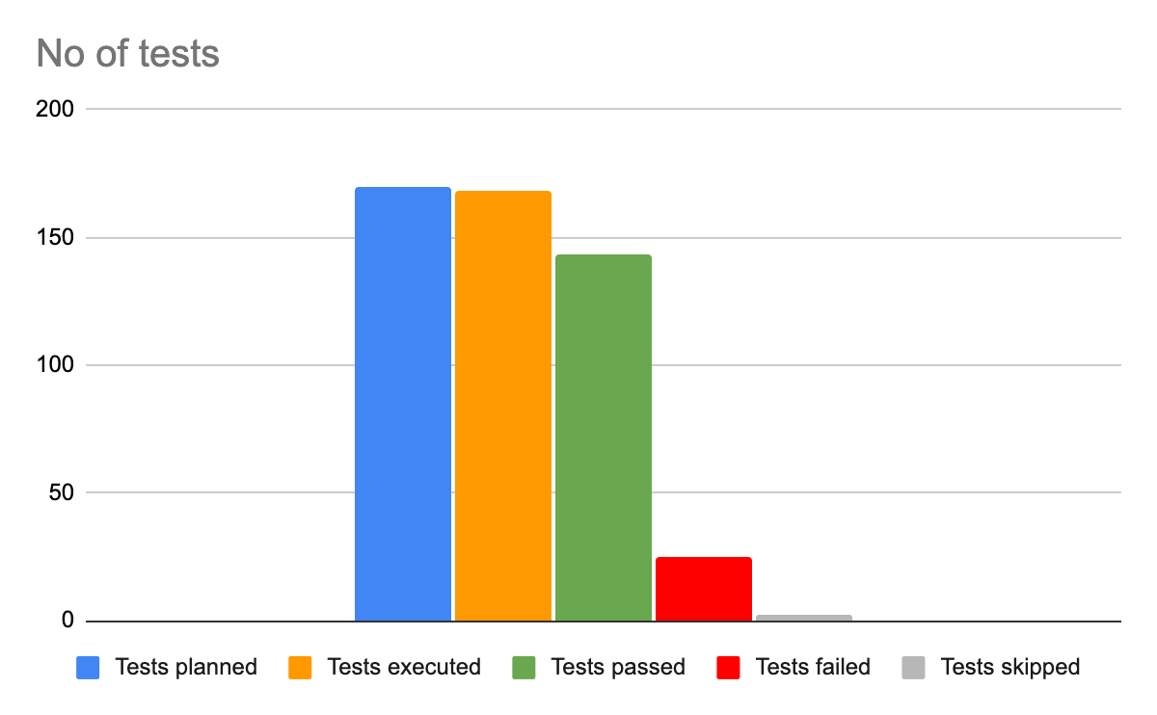

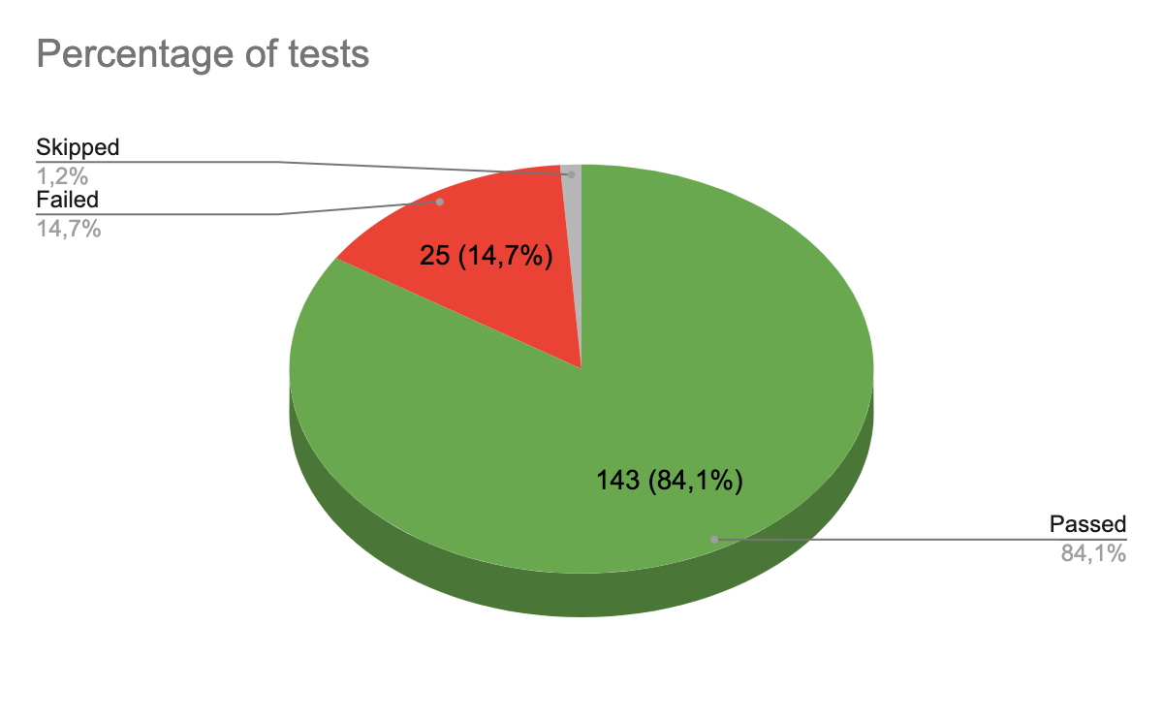

1. *Defects distribution - module wise:*

| Registration form | Login form | Password recovery | Main | Buy | Schedules | Dance styles | Trainers | Account |
| --- | --- | --- | --- | --- | --- | --- | --- | --- |
| 4 | 4 | 2 | 6 | 2 | 2 | 1 | 3 | 6 |

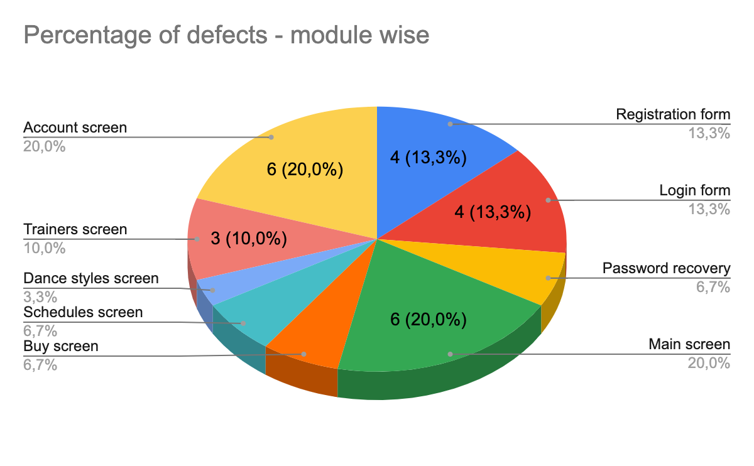

**5.2.2 Iphone 7 plus:**

1. *Numbers of tests planned/executed and passed/failed:*

| Test planned | Tests executed | Tests passed | Tests failed | Tests skipped |
| --- | --- | --- | --- | --- |
| 170 | 168 | 142 | 26 | 2 |

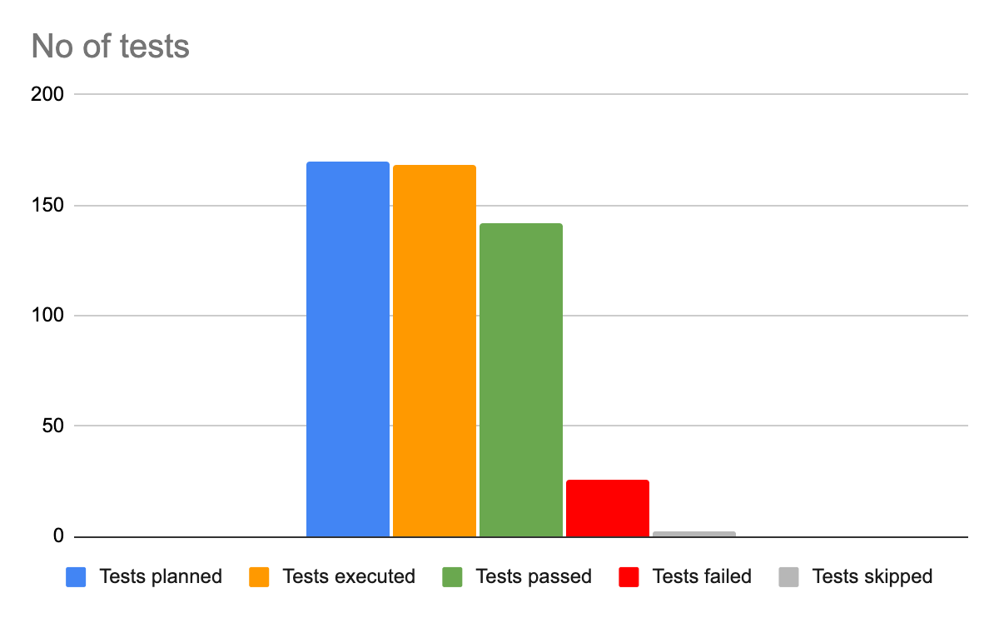

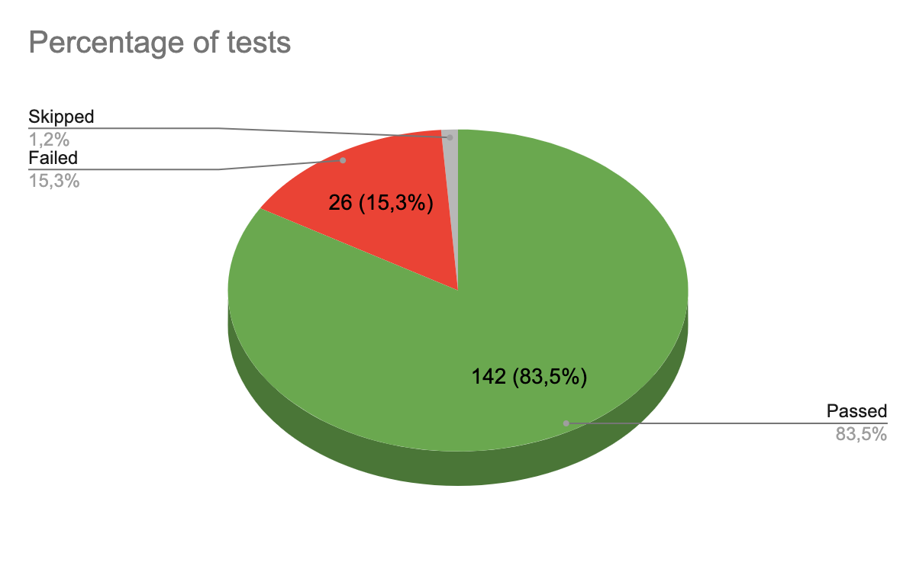

1. *Defects distribution - module wise:*

| Registration form | Login form | Password recovery | Main | Buy | Schedules | Dance styles | Trainers | Account |
| --- | --- | --- | --- | --- | --- | --- | --- | --- |
| 4 | 4 | 2 | 6 | 3 | 2 | 1 | 3 | 6 |

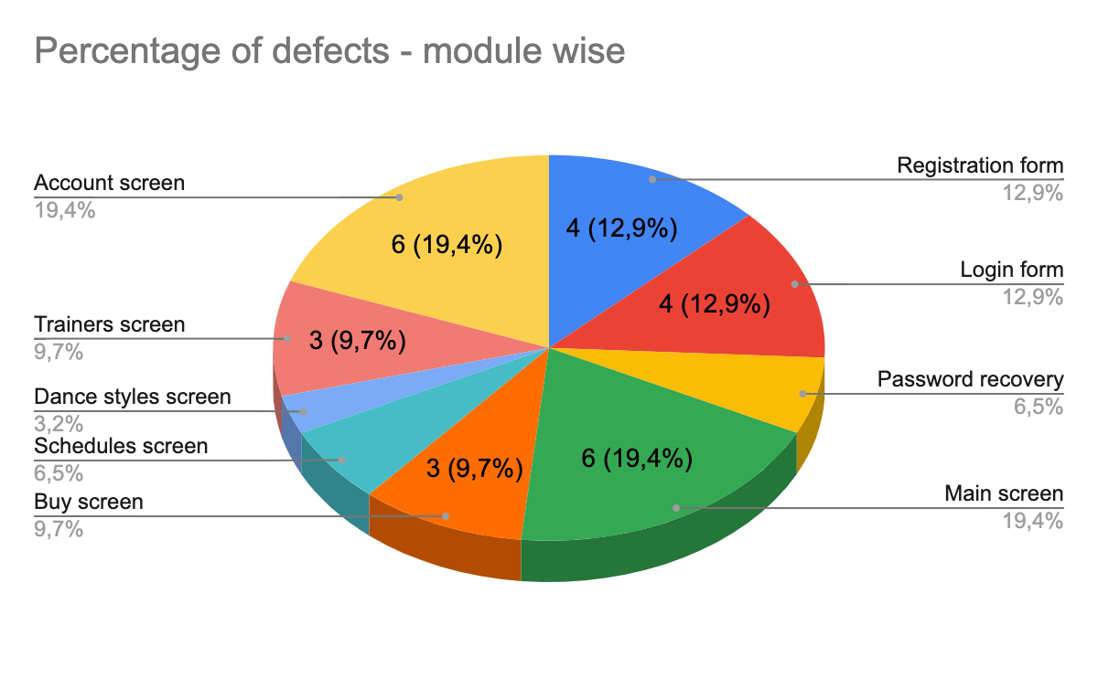

**5.3 Numbers of defects and their severity.**

| Trivial | Minor | Major | Critical | Blocker | Total |
| --- | --- | --- | --- | --- | --- |
| 13 | 24 | 5 | 3 | 2 | 47 |

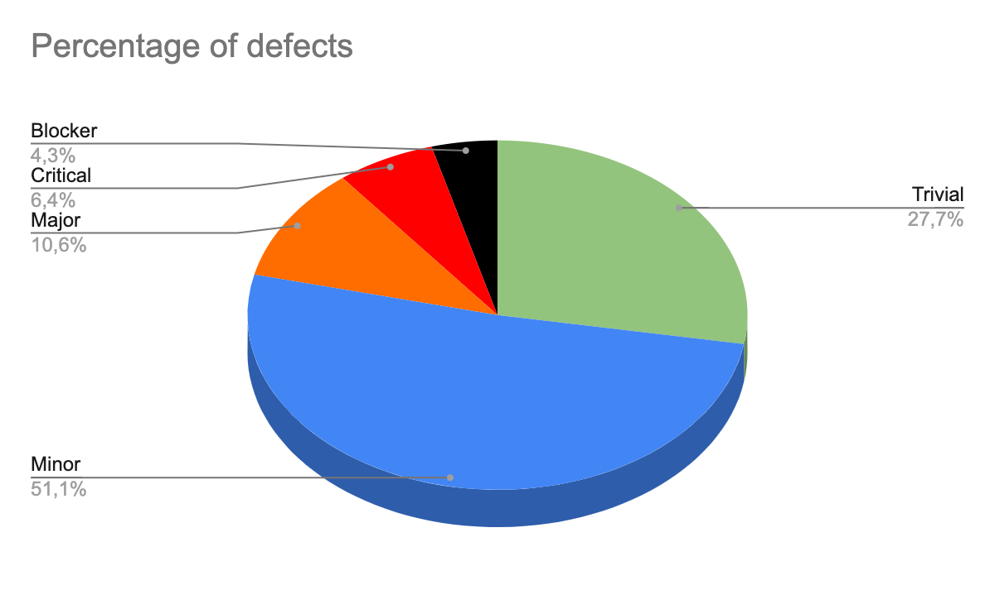

**6. Exit criteria.**

**6.1 All planned tests should be executed:**

1. Functional testing - 98% of the planned tests have been completed.
2. GUI testing - 98% of the planned tests have been completed.

**6.2 All critical errors should be fixed - The test team doesn't yet have information about the fixed defects.**

**6.3 Testing can be considered complete when all planned tests have been executed and 95% of all errors have been corrected, with no critical/blocker errors remaining - THIS ITEM HAS NOT YET BEEN COMPLETED.**

**7. Conclusion.**

As the exit criteria were not met the test team does not recommend this mobile app for use by the general public until 95% of all errors are fixed and there are no critical/blocker errors.